Maxta’s MaxDeploy Reference Architecture With Mirantis OpenStack

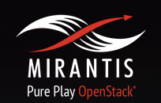

Key Solution Benefits
The combination of Matxa MxSP with Mirantis OpenStack provides a cost-effective yet powerful cloud and data center solution. This solution delivers high performance for a range of workloads, at an attractive cost, that is easy to manage and scales flexibly to meet current and future needs. Other important benefits include:
- Deliver full breadth of technology, integration, training, and support
- Provides VM-centric enterprise-class reliability and data services
- Delivers independent and on-demand scale-up and scale-out of compute and storage resources
- Dramatically simplifies IT by eliminating storage arrays, storage management & storage networking
- Eliminates vendor lock-in
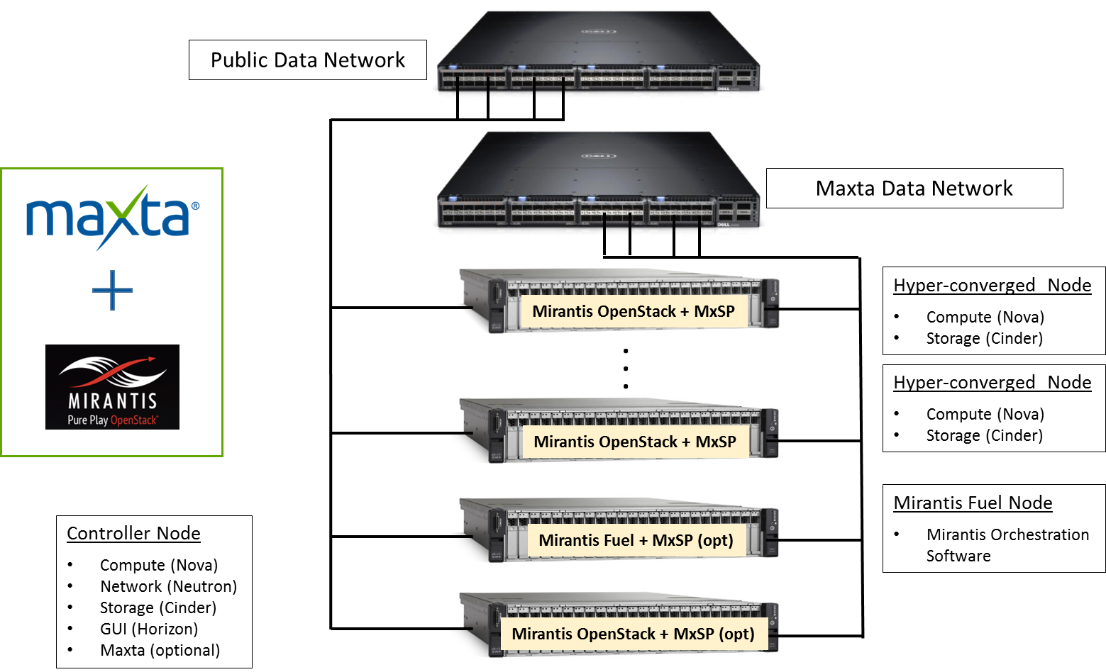
Figure 1: Configuration Topology

Components of the Solution

Maxta Storage Platform
The Maxta Storage Platform (MxSP) is a hypervisor-agnostic, highly resilient storage platform for the virtual data center, and is helping transform the enterprise storage market. It fully integrates with server virtualization at all levels from user interface to data management, while supporting all possible deployments of virtual data centers, including private, public and hybrid clouds. Through its software-only solution, MxSP turns standard servers into a converged compute and storage solution, leveraging server-side flash and disk drives to optimize performance and capacity. MxSP’s distributed architecture enables shared storage with enterprise-class data services such as snapshots, clones, thin provisioning, compression, de-duplication, replication as well as full scale-out without performance degradation. This results in dramatically simplifying IT and significant cost savings.
The innovative, peer-to-peer architecture aggregates storage resources from multiple servers, assimilating a global namespace, creating a shared storage pool. An instance of MxSP software is installed on each of the servers that are part of the virtualization cluster. The storage resources are a combination of magnetic disk drives and SSD. All the servers running MxSP software have access to the aggregated storage pool.
MxSP intelligently maps VMs to storage resources, optimizing data layout for virtual workloads and leverages SSDs for read/write caching. It dramatically improves performance and eliminates the need for IT administrators to make difficult tradeoffs between performance and cost.

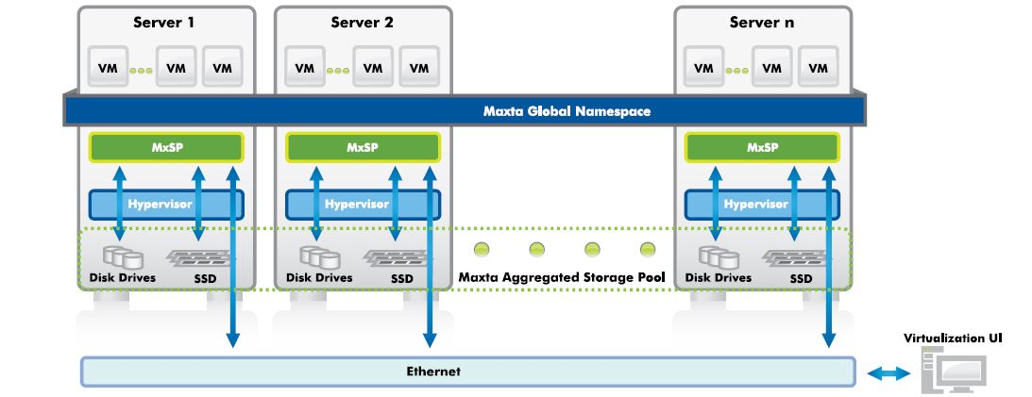

Mirantis OpenStack Platform
Mirantis OpenStack, the original zero lock-in distribution, gives customers the speed-to-market of deploying and managing OpenStack. Mirantis has taken real-world OpenStack production deployments and packaged them up into the Mirantis OpenStack distribution, with Fuel, a single control plane for your entire cloud. This solution automatically discovers new servers, configures and verifies your network and tests your deployment.

Fuel is an open source deployment and management tool for OpenStack. It provides an intuitive, GUI-driven experience for deployment and management of OpenStack distributions and plug-ins. Fuel brings consumer-grade simplicity to streamline and accelerate the otherwise time-consuming, often complex, and error-prone process of deploying various configuration flavors of OpenStack at scale.

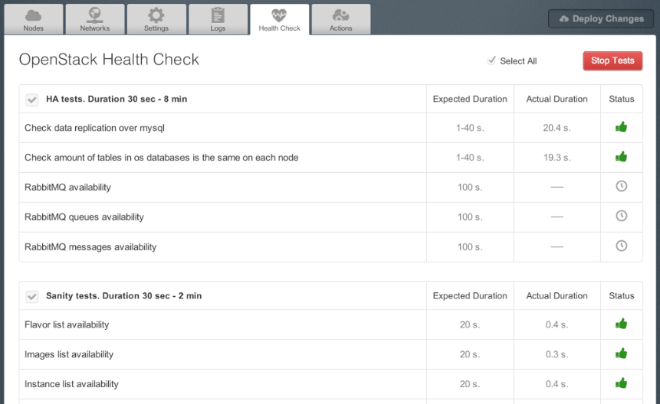

System Configuration Information
Components | Description
Number of servers | Intel (White box)
Processor per server | Dual-Socket 8 cores (Intel Xeon® CPU E5-2640 V3 @ 2.60GHz)
Memory per server | 128 GB DDR4
HDDs per server | 8x1TB 7.2K RPM SATA
SSDs per server | 2x400GB SATA (Intel DC S3700)
Network configuration | Dedicated 10 GigE port
Software products | Mirantis OpenStack  Maxta Storage Platform
Performance per server | 10,000+ IOPS @ 4K Block Size (80% Read 100% Random)  30,000+ IOPS @ 4K Block Size (100% Read 100% Random)

Benefits of the Solution
Dramatically Simplify IT – Manage VMs, NOT storage:
The solution dramatically simplifies IT by eliminating the need for storage provisioning and managing volumes, LUNs, file systems, and RAID. Nova and Cinder driver plug-ins enable the joint solution to deliver all data services such snapshots and zero-copy clones by configuring and managing them from Horizon UI at the VM-level rather than from a storage specific UI at the storage-level. This enables OpenStack administrators to leverage storage without the need for deep storage and vendor specific expertise. This simplification, along with converged compute and storage, eliminates the day-to-day tasks of storage management and enables administrators to focus on managing applications and VMs.

Deliver Full Breadth of Technology, Integration, Training and Support – Provides Enterprise-class Services:
The revolutionary solution achieves best-in-class resiliency and high availability, with end-to-end data integrity, and no single point of failure. There is no compromise to the enterprise-class features that you would typically receive from a storage array. The joint solution empowers a fully integrated OpenStack cloud or data center platform

Maximize CAPEX and OPEX Savings – Leverage Convergence and Intel Server Boards and System Servers:
MaxDeploy, reference architecture with Mirantis OpenStack, converges compute and storage resources on industry standard Intel servers, eliminating the need for storage arrays and storage networking without compromising performance or scalability. This provides considerable up-front capital savings and even greater savings on upgrades compared to the capital expenses associated with purchasing and expanding storage arrays or storage appliances. In addition, leveraging commodity disk drives, SSDs, snapshots, zero-copy clones, thin provisioning, in-line compression and in-line de-duplication increases storage efficiency and reduces storage expenses. By significantly simplifying IT, increasing IT efficiency and enabling OpenStack, administrators dramatically reduce their operating expenses and can eliminate a significant amount of storage complexity and administration.

Conclusion
The MaxDeploy reference architecture delivers on the promise of a hyper-convergence for cloud and data centers based on OpenStack thereby eliminating the need for SAN or NAS storage. This deployment provides a pre-defined and validated set of hardware and storage software for OpenStack. The architecture delivers the ability to combine the best-in-class technology for compute, storage and networking components. This delivers a simple and cost effective OpenStack cloud and data centers platform without compromising any features or performance. For more information visit http://www.maxta.com/solutions or contact Maxta at sales@maxta.com.

Maximize the promise of hyper-convergence!
100 Mathilda Place, #170, Sunnyvale, CA 94086
(408) 789-5149
Email sales@maxta.com
www.maxta.com
© 2014 Maxta. All rights reserved. Maxta, MxSP, and MaxDeploy are trademarks of Maxta Inc. All other trademarks are the property of their respective owners.


